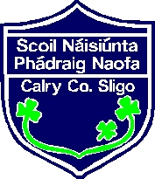
St.Patrick’s NS, Calry
Sixth Class Booklist 2022-23
Gaeilge: Foclóir (Dictionary)
Craic Le Litriu E – Gill & Macmillan

English: Chambers English Dictionary
Spelling workbook provided in school

Mathematics: Busy at Maths 6 (Fallons)
New Wave Mental Maths 6
Tables champion 6

Religion: Grow in Love – Sixth Class
Art & craft: Empty 750g/1kg cereal box to make art portfolio.

History/ Geography/ Science- Book Rental Scheme
Just Maps Workbook - 6th Class

Copies: 1 plastic box for books
5 copies 80 page
5 copies 120 page
3 squared copies
2 Hardback Notebooks ----- 1 Large (A4) & 1 Small
1 Thick Scrapbook for Confirmation pages
3 plastic envelope Folders
1 Lever Arch Folder & dividers & plastic Pockets
3 Pritt Stick(Labelled)
2 Handwriting copies ASXB4 (purple)
1 scissors – labelled

Electronic link will be emailed in September for €60 Art & Craft, Book Rental,Homework Journal, spelling workbook & Dabbledoo Subscription.

Alice Mc Nassor

